Ex No.5 Simulate a cloud scenario using CloudSim and run a scheduling algorithm that is not present in CloudSim
Aim
To simulate a cloud scenario using CloudSim and run a scheduling algorithm that is not present in CloudSim.

Softwares Required
- Eclipse 2019-12
- jdk 18.0.2.1
- Cloudsim 3.0.3
Cloudsim
CloudSim is a framework for modeling and simulation of cloud computing infrastructures and services. CloudSim comprises huge volume of libraries for simulating the cloud based computing systems. It offers necessary classes for creating users, applications, virtual machines, data centers, computational resources and policies for controlling the different parts of the system as provisioning and scheduling.
Installation
1. Download the eclipse from the following link
https://www.eclipse.org/downloads/packages/release/2019-12/r
2. Download the jdk 18.0.2.1 from the link
https://www.oracle.com/java/technologies/javase/jdk18-archive-downloads.html
3. Download the cloudsim 3.0.3 and extract the files.
https://github.com/Cloudslab/cloudsim/releases/tag/cloudsim-3.0.3

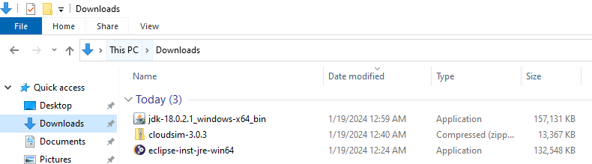

- Run eclipse. Select eclipse IDE for Java Developers.
- Select the folder to install the eclipse.
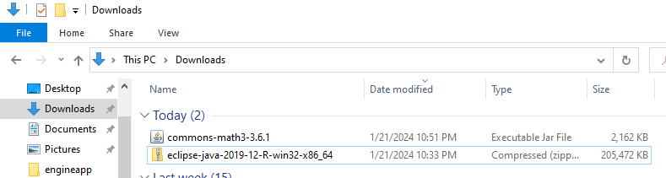

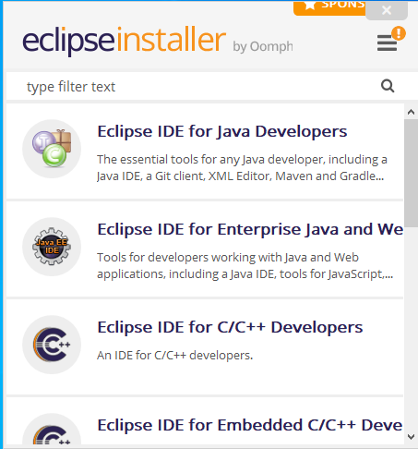

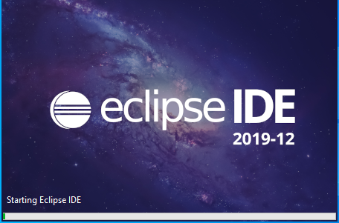

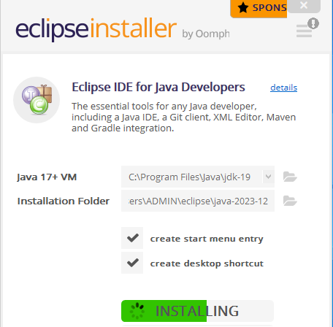
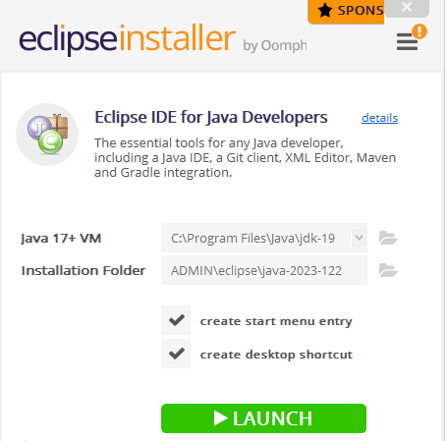
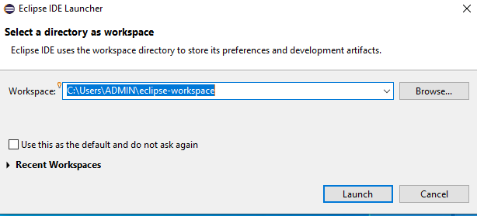

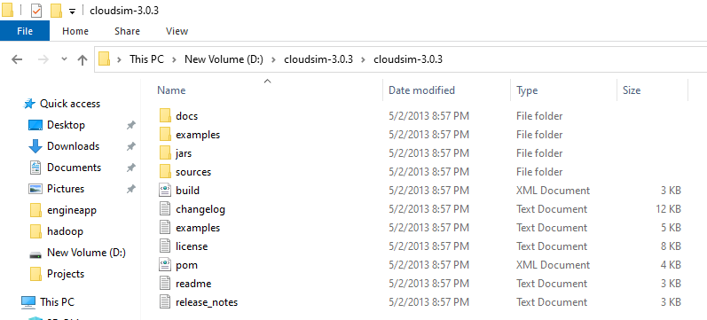

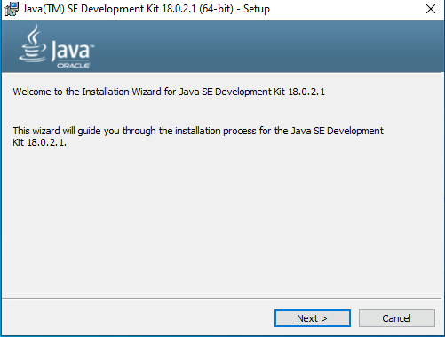

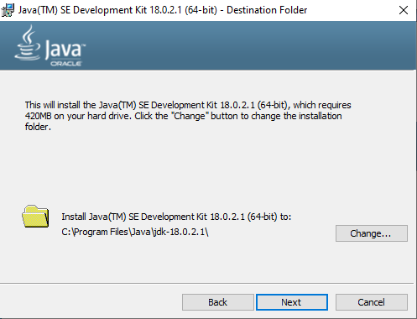

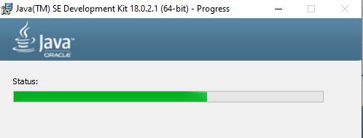

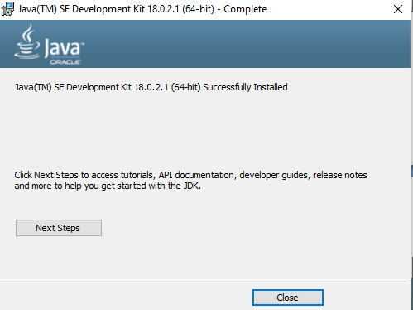

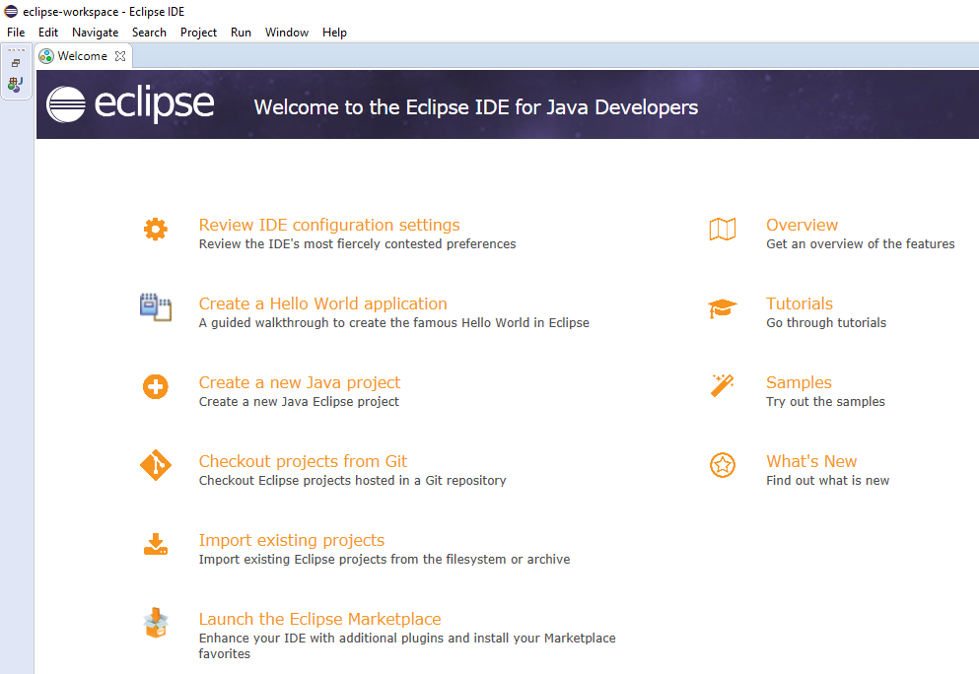

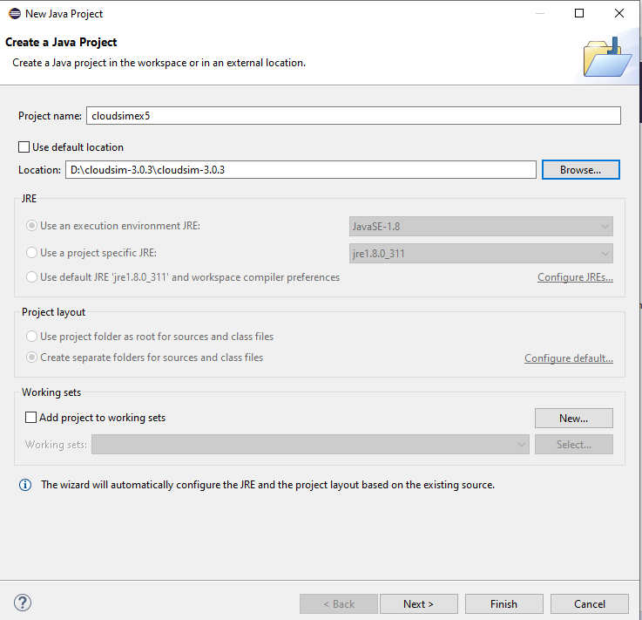
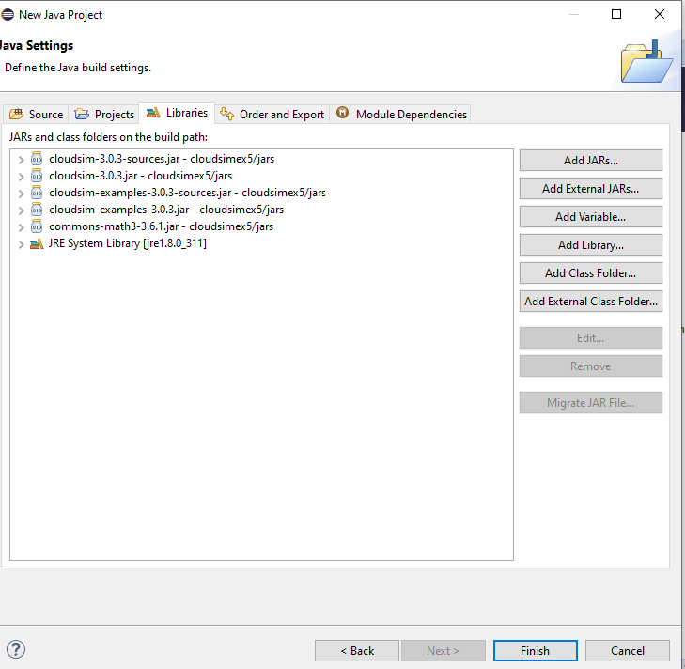

FCFS_Scheduler.java
package org.cloudbus.cloudsim.examples;
import org.cloudbus.cloudsim.*;
import org.cloudbus.cloudsim.core.CloudSim;
import utils.Constants;
import utils.DatacenterCreator;
import utils.GenerateMatrices;
import java.text.DecimalFormat;
import java.util.Calendar;
import java.util.LinkedList;
import java.util.List;
public class FCFS_Scheduler {

private static List<Cloudlet> cloudletList;
private static List<Vm> vmList;
private static Datacenter[] datacenter;
private static double[][] commMatrix;
private static double[][] execMatrix;

private static List<Vm> createVM(int userId, int vms) {
//Creates a container to store VMs. This list is passed to the broker later
LinkedList<Vm> list = new LinkedList<Vm>();

//VM Parameters
long size = 10000; //image size (MB)
int ram = 512; //vm memory (MB)
int mips = 250;
long bw = 1000;
int pesNumber = 1; //number of cpus
String vmm = "Xen"; //VMM name

//create VMs
Vm[] vm = new Vm[vms];

for (int i = 0; i < vms; i++) {
vm[i] = new Vm(datacenter[i].getId(), userId, mips, pesNumber, ram, bw, size, vmm, new CloudletSchedulerSpaceShared());
list.add(vm[i]);
}

return list;
}

private static List<Cloudlet> createCloudlet(int userId, int cloudlets, int idShift) {
// Creates a container to store Cloudlets
LinkedList<Cloudlet> list = new LinkedList<Cloudlet>();

//cloudlet parameters
long fileSize = 300;
long outputSize = 300;
int pesNumber = 1;
UtilizationModel utilizationModel = new UtilizationModelFull();

Cloudlet[] cloudlet = new Cloudlet[cloudlets];

for (int i = 0; i < cloudlets; i++) {
int dcId = (int) (Math.random() * Constants.NO_OF_DATA_CENTERS);
long length = (long) (1e3 * (commMatrix[i][dcId] + execMatrix[i][dcId]));
cloudlet[i] = new Cloudlet(idShift + i, length, pesNumber, fileSize, outputSize, utilizationModel, utilizationModel, utilizationModel);
// setting the owner of these Cloudlets
cloudlet[i].setUserId(userId);
cloudlet[i].setVmId(dcId + 2);
list.add(cloudlet[i]);
}
return list;
}

public static void main(String[] args) {
Log.printLine("Starting FCFS Scheduler...");

new GenerateMatrices();
execMatrix = GenerateMatrices.getExecMatrix();
commMatrix = GenerateMatrices.getCommMatrix();

try {
int num_user = 1; // number of grid users
Calendar calendar = Calendar.getInstance();
boolean trace_flag = false; // mean trace events

CloudSim.init(num_user, calendar, trace_flag);

// Second step: Create Datacenters
datacenter = new Datacenter[Constants.NO_OF_DATA_CENTERS];
for (int i = 0; i < Constants.NO_OF_DATA_CENTERS; i++) {
datacenter[i] = DatacenterCreator.createDatacenter("Datacenter_" + i);
}

//Third step: Create Broker
FCFSDatacenterBroker broker = createBroker("Broker_0");
int brokerId = broker.getId();

//Fourth step: Create VMs and Cloudlets and send them to broker
vmList = createVM(brokerId, Constants.NO_OF_DATA_CENTERS);
cloudletList = createCloudlet(brokerId, Constants.NO_OF_TASKS, 0);

broker.submitVmList(vmList);
broker.submitCloudletList(cloudletList);

// Fifth step: Starts the simulation
CloudSim.startSimulation();

// Final step: Print results when simulation is over
List<Cloudlet> newList = broker.getCloudletReceivedList();
//newList.addAll(globalBroker.getBroker().getCloudletReceivedList());

CloudSim.stopSimulation();

printCloudletList(newList);

Log.printLine(FCFS_Scheduler.class.getName() + " finished!");
} catch (Exception e) {
e.printStackTrace();
Log.printLine("The simulation has been terminated due to an unexpected error");
}
}

private static FCFSDatacenterBroker createBroker(String name) throws Exception {
return new FCFSDatacenterBroker(name);
}

/**
* Prints the Cloudlet objects
*
* @param list list of Cloudlets
*/
private static void printCloudletList(List<Cloudlet> list) {
int size = list.size();
Cloudlet cloudlet;

String indent = " ";
Log.printLine();
Log.printLine("========== OUTPUT ==========");
Log.printLine("Cloudlet ID" + indent + "STATUS" +
indent + "Data center ID" +
indent + "VM ID" +
indent + indent + "Time" +
indent + "Start Time" +
indent + "Finish Time");

DecimalFormat dft = new DecimalFormat("###.##");
dft.setMinimumIntegerDigits(2);
for (int i = 0; i < size; i++) {
cloudlet = list.get(i);
Log.print(indent + dft.format(cloudlet.getCloudletId()) + indent + indent);

if (cloudlet.getCloudletStatus() == Cloudlet.SUCCESS) {
Log.print("SUCCESS");

Log.printLine(indent + indent + dft.format(cloudlet.getResourceId()) +
indent + indent + indent + dft.format(cloudlet.getVmId()) +
indent + indent + dft.format(cloudlet.getActualCPUTime()) +
indent + indent + dft.format(cloudlet.getExecStartTime()) +
indent + indent + indent + dft.format(cloudlet.getFinishTime()));
}
}
double makespan = calcMakespan(list);
Log.printLine("Makespan using FCFS: " + makespan);
}

private static double calcMakespan(List<Cloudlet> list) {
double makespan = 0;
double[] dcWorkingTime = new double[Constants.NO_OF_DATA_CENTERS];

for (int i = 0; i < Constants.NO_OF_TASKS; i++) {
int dcId = list.get(i).getVmId() % Constants.NO_OF_DATA_CENTERS;
if (dcWorkingTime[dcId] != 0) --dcWorkingTime[dcId];
dcWorkingTime[dcId] += execMatrix[i][dcId] + commMatrix[i][dcId];
makespan = Math.max(makespan, dcWorkingTime[dcId]);
}
return makespan;
}
}
FCFSDatacenterBroker.java
package org.cloudbus.cloudsim.examples;
import org.cloudbus.cloudsim.Cloudlet;
import org.cloudbus.cloudsim.DatacenterBroker;
import org.cloudbus.cloudsim.Log;
import org.cloudbus.cloudsim.core.CloudSim;
import org.cloudbus.cloudsim.core.SimEvent;
import java.util.ArrayList;

public class FCFSDatacenterBroker extends DatacenterBroker {

public FCFSDatacenterBroker(String name) throws Exception {
super(name);
}

//scheduling function
public void scheduleTaskstoVms() {
ArrayList<Cloudlet> clist = new ArrayList<Cloudlet>();
for (Cloudlet cloudlet : getCloudletSubmittedList()) {
clist.add(cloudlet);
}

setCloudletReceivedList(clist);
}

@Override
protected void processCloudletReturn(SimEvent ev) {
Cloudlet cloudlet = (Cloudlet) ev.getData();
getCloudletReceivedList().add(cloudlet);
Log.printLine(CloudSim.clock() + ": " + getName() + ": Cloudlet " + cloudlet.getCloudletId()
+ " received");
cloudletsSubmitted--;
if (getCloudletList().size() == 0 && cloudletsSubmitted == 0) {
scheduleTaskstoVms();
cloudletExecution(cloudlet);
}
}

protected void cloudletExecution(Cloudlet cloudlet) {

if (getCloudletList().size() == 0 && cloudletsSubmitted == 0) { // all cloudlets executed
Log.printLine(CloudSim.clock() + ": " + getName() + ": All Cloudlets executed. Finishing...");
clearDatacenters();
finishExecution();
} else { // some cloudlets haven't finished yet
if (getCloudletList().size() > 0 && cloudletsSubmitted == 0) {
// all the cloudlets sent finished. It means that some bount
// cloudlet is waiting its VM be created
clearDatacenters();
createVmsInDatacenter(0);
}

}
}
}

Constants.java
package utils;
public class Constants {
public static final int NO_OF_TASKS = 30; // number of Cloudlets;
public static final int NO_OF_DATA_CENTERS = 5; // number of Datacenters;
public static final int POPULATION_SIZE = 25; // Number of Particles.
}

Output

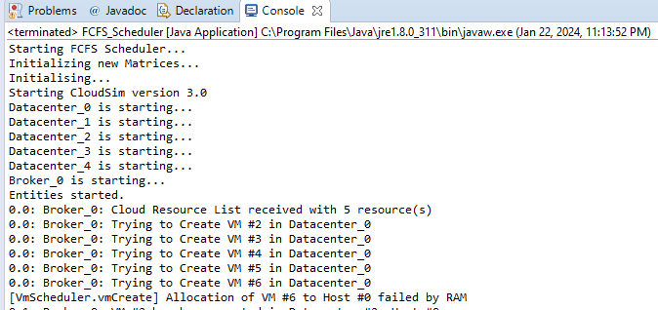
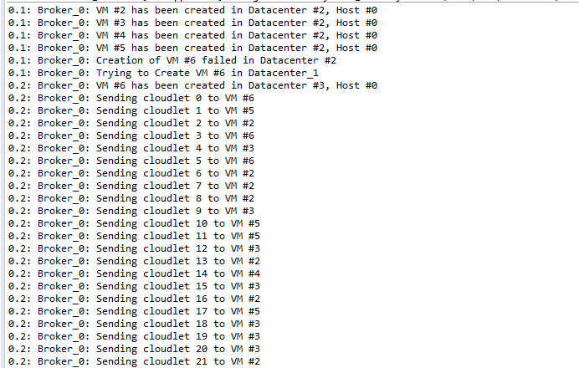
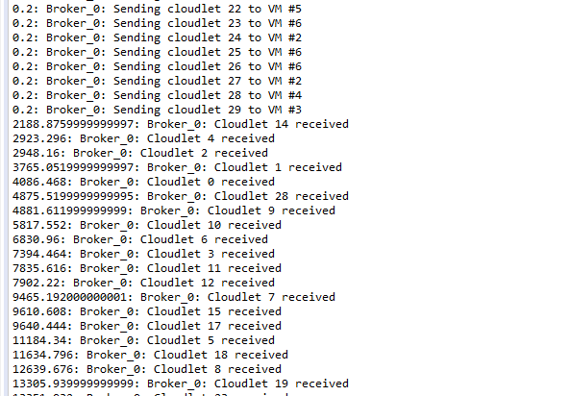
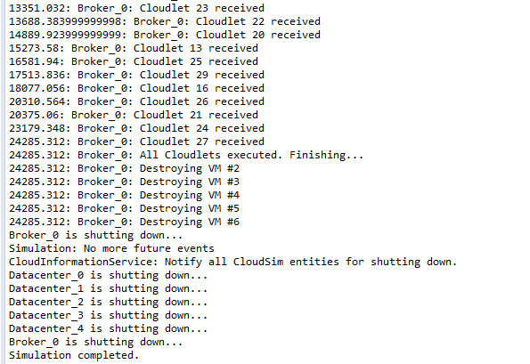
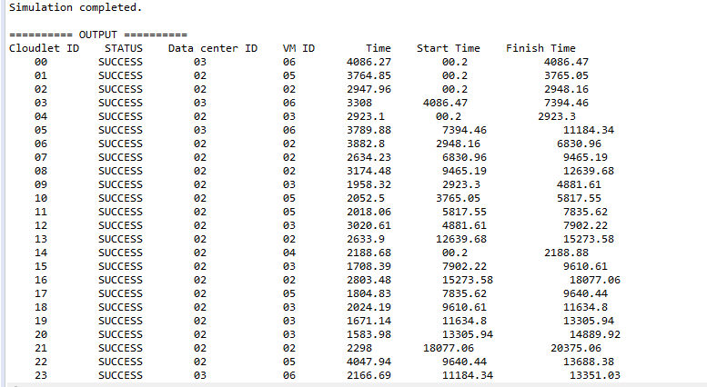
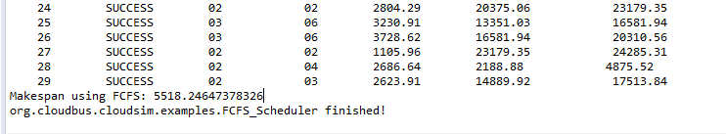

Result
Thus the scheduling algorithm was executed using CloudSim.

